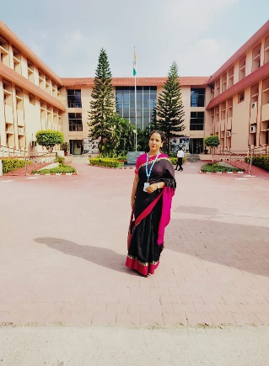

**Seema Pandey Vashishta**

Assistant Professor

Education Department, Nimbus School of Education, Dehradun (U.K)

**Area:**

EDUCATION

ENGLISH LITERATURE

POLTICAL SCIENCE

**Contact:**

[Email-pandeysimi221@gmail.com](mailto:Email-pandeysimi221@gmail.com)

Phone: +91-7895028787

**Education:**

Pursuing Ph.D. in Education from S.G.R.R. UNIVERSITY Dehradun.

M.Ed. from H.N.B.G University (2018).

M.A English from H.N.B.G University (2014)

M.A Political Science from Swami Vivekananda university (2020).

B.Ed. from H.N.B.G. University. (2013)

B.A(English, Political Science, Geography) from H.N.B.G University. (2011)

Qualified – UTET 1ST and 2nd (2013) andUTET 2nd (2014) & CTET 2nd (2018)

**Teaching**:

Knowledge and curriculum.

Gender school and society.

English Literature.

**Research area**:

Stress, Confidence and Social Maturity.

Indian Educational Policies.

**Academic Experience**:

4 years’ teaching experience in B.Ed. college (Nimbus school of education) as an Assistant professor.

**Professional Experience:**

Nimbus School of Education

Nimbus Academy of management

**Selected Publication**:

* Research paper published in journal of positive school of psychology on the topic “**A study of the confidence of higher secondary level students with respect to their social evolving”. (2022)**

**Academic Conference**:

* Attended National Conference on **Significance of Yoga Education for Development of Teaching and Teacher education.**
* Presented a research paper on **Social Support and Persistency to Stress** in International Conference on Multidisciplinary Research & Development.
* Presented a research paper on **stress in adolescence and value education** in national seminar.
* Attended ICSSR Sponsored NationalSeminar on **New Education Policy 2019 and its Impact on Disability Studies.**